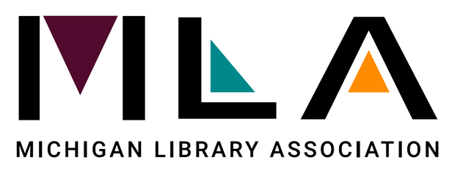

Michigan Library Appreciation Month October 2021
Proclamation

Whereas, The Michigan Library Association (MLA) annually designates the month of October as a statewide observance to celebrate the contributions of Michigan's libraries, librarians and library staff;

Whereas, Michigan's libraries (school, public, academic, tribal, cooperatives, and special libraries) are vital, dynamic centers of discovery and lifelong learning, serving as cornerstones in healthy communities;

Whereas, librarians and library workers play key roles in connecting their community members to resources and information, helping people explore, imagine and discover new horizons in the vast world of information, knowledge and entertainment;

Whereas, today’s libraries are less about what they have on the shelves and more about what they can do with and for their communities, whether it’s through virtual services or in-person visits;

Whereas, libraries and librarians work to create an equitable society by providing free access to accurate information to all people;

Whereas, in times of crisis, libraries and library staff play a critical role in continuing to support their communities when they need it the most;

Whereas, libraries bring together diverse populations and are a resource for all members of the community regardless of race, ethnicity, creed, ability, sexual orientation, gender identity or socio-economic status;

Whereas, libraries strive to develop and maintain programs and collections that are as diverse as the populations they serve;

Whereas, libraries serve as a vital connection to the people, places and ideas of the world through books, magazines, videos and the Internet and are the primary point of online access for people without computers at home, school or work;

Whereas, libraries provide indispensable educational resources for children and teenagers, and are on the front lines in the battle against illiteracy, offering plenty of free activities, as well as safe, enriching entertainment for the whole family;

Whereas, one-half of all Michiganders hold library cards, and in 2020, visited their local libraries in-person more than 33 million times, virtually nearly 55 million times, and borrowed over 57 million physical items and close to 12 million eMaterials;

Whereas, in 2020, Michigan public libraries provided more than 13,000 live virtual programs for children, teens and adults reaching over 608,000 people;

Whereas, during the worldwide pandemic in 2020, 76% of Michigan’s public libraries offered curbside services and 82% continued to provide reference services via phone and internet - providing a way to continue getting information and materials to residents even when library buildings were closed to the public;

Whereas, hundreds of libraries and millions of library supporters across Michigan are celebrating Michigan Library Appreciation Month this October; now, therefore, be it

Resolved that I, [name, title of official] proclaim October 2021 as Michigan Library Appreciation Month. During this time, I encourage all residents to visit their library in person or virtually to connect to the myriad of services, resources and collections their library provides.

