Tips for Researching Your Family Tree

Start Your Family Tree

Start with what you know. Immediate family often holds the key when it comes to family history research. Interview your family members and record the memories they share with you. Ask relatives about specific individuals and gather details including nicknames, where they lived, occupations, and vital information such as birth, marriage, and death dates. Using an online family tree will help you to organize your results and build solid foundations as you explore.

Search Your Home for Scrapbooks/Gather Materials from Relatives

Important clues may be found in family scrapbooks, birth certificates, school records, family Bibles, diaries, letters, photographs, and memorabilia boxes. Some family members may have old genealogical information they have researched and/or information passed along from other relatives.

Join the Family History Conversation/Find a Family History Society

Join a network of family historians on social networking resources like familyhistory.com, findmypast.com, and ancestry.com to make connections and expand your resources.

Start with a Family Story/Search One Family Story at a Time

Identify a story about family members you are interested in exploring, and then uncover newspaper articles and records that relate to the story. Stories include military service (service records), occupation (first paycheck), educational (attending high school or college), or a family legend (descendants from prominent figures of history). Focus on 1-2 families at a time to keep research organized and maintain productivity; then “connect the dots” later.

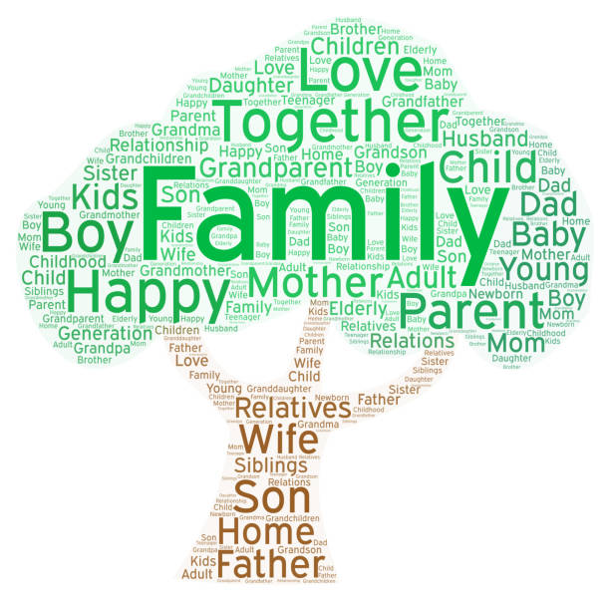

5 Tips for Searching U.S. Census Records

1. Can’t find Grandma? Look for someone else!

If you have conducted a thorough search of the census index for a given year, but continue to come up empty, look to your family group sheets for help. Did you ancestor have a sibling with an unusual or uncommon name? It is easier to find “Melvin” than “Mary;” gender does not matter as long as the ages were close enough that they would be living under the same roof. Try using one or more uncommon given names and then scan the results looking for siblings that match the person you are truly seeking.

2. Search without a name.

Sometimes, there are combinations of errors that may result with your ancestor hiding in plain sight; the census enumerator may have written a name incorrectly. Use location, gender, age, relationship, and birth place to filter out names that do not match. Searching a particular state, county, and city/township for a 12-year old son in Virginia already narrows down the number of results. If the results are large, add in one or both parents’ names. If the results are too few, remove the parents, and add the name of one other person likely living as a member of the household.

3. Use approximate year of birth.

Census officials had to rely upon the information from each family being correct, but sometimes there were complications such as women aging only 5-6 between census decades and in the changing of the census date itself. Rather than specifying an exact year for your family member, allow some room for error. If your notes show the birth year as 1904, try using 1904 plus/minus 2 years; expand or narrow your selection based upon the number of results found.

4. Establish bookends.

When using census records, it is always wise to consider the range of possible years for the birth and death dates of your ancestors. If your great great grandfather was born in 1823 and died at the age of 62, then 1885 would be the approximate year of death. The first US census he could have appeared in was 1830 and the last would be 1880. This gives you 6 chances to find him in the census. Census bookends will prevent wasted effort in looking for a person in a census before they were born or after they died.

5. Walk backwards through time.

Generally, it is easier to find your ancestors as you move backward through time, especially for census records. In the previous example, there were 6 years to search for your great great grandfather. By starting with the 1880 census, you will find his name, occupation, approximate year of marriage, names of family members, place of birth, and the place of birth for his father and mother.

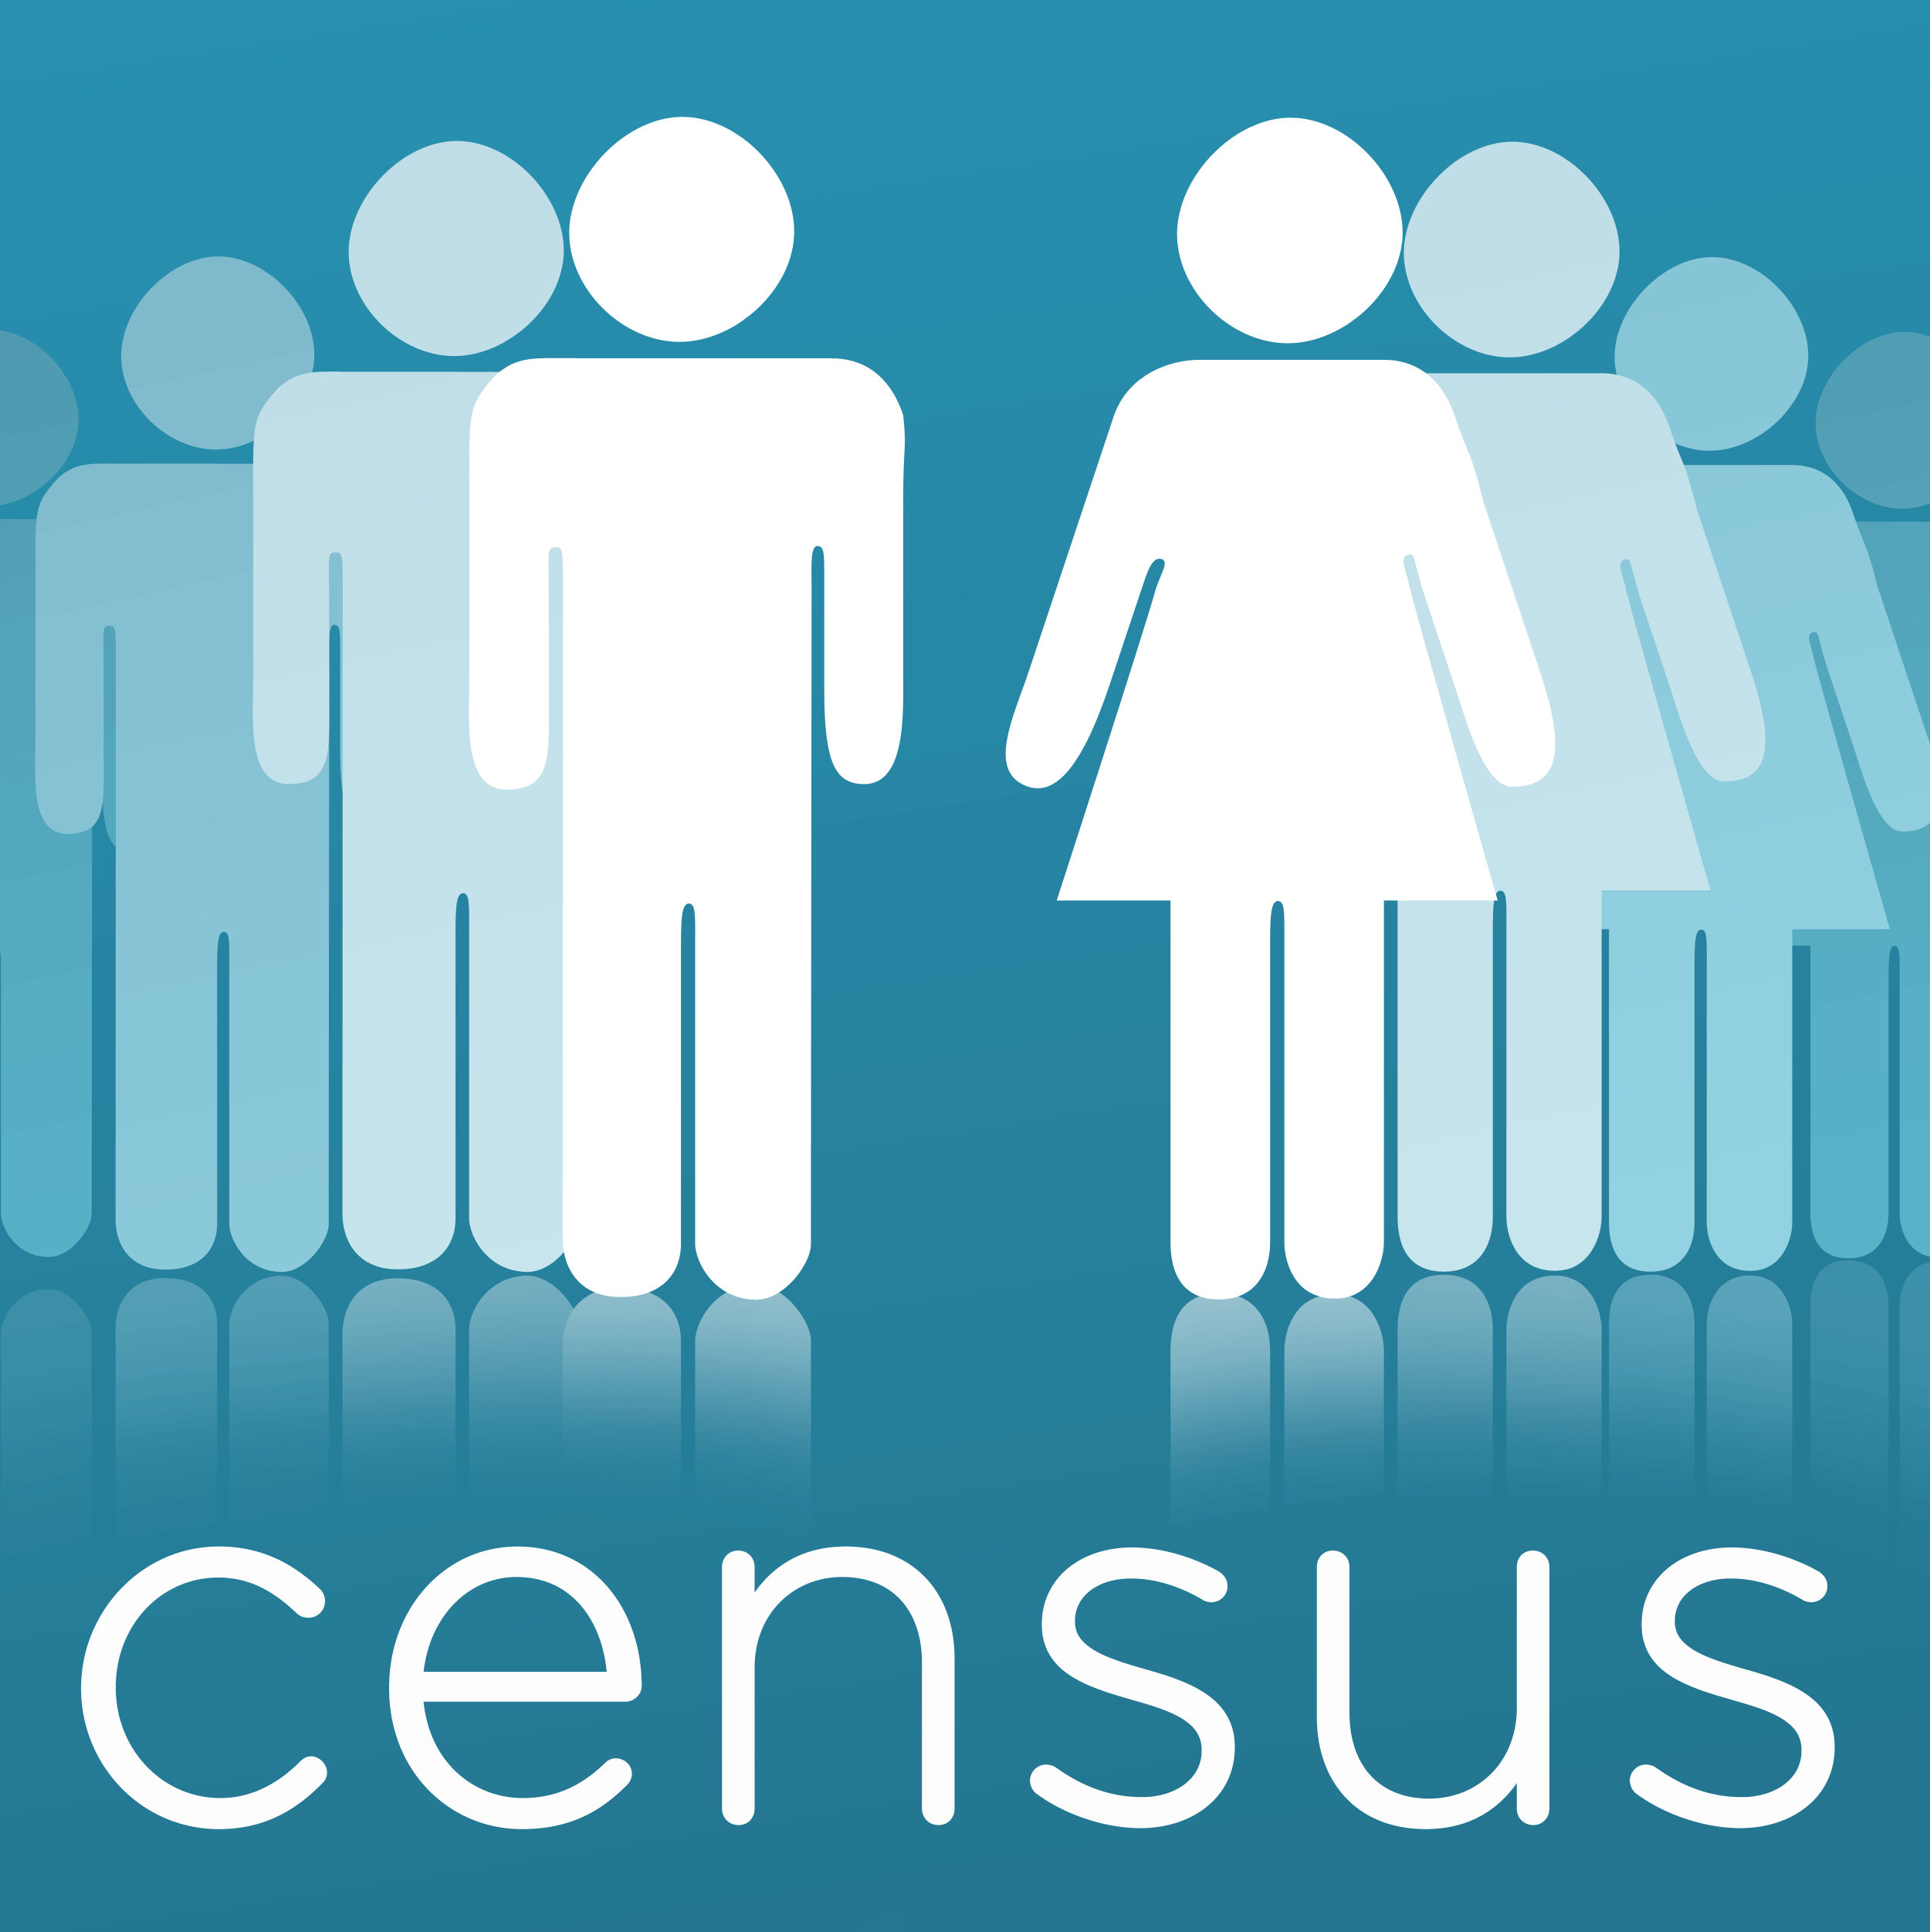

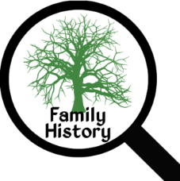Family History Resources

Census Records

This is the largest resource for family history and the most solid place to start. The U.S. Federal census began in 1790 and includes names, ages, birthplaces, immigration details, occupations, and residences.

Birth, Marriage, and Death Records

“Vital records” are a key tool for family history research and include birth, marriage, and death records. These are kept by state rather than nationwide, and most began to be recorded in the 1880s to now, although there are some exceptions.

Family History Stories

Family Bibles, letters, diaries, and other materials in your home or those of your relatives are unique sources that may yield great results. Reach out to extended family and those who have done previous family research.

Newspapers

Newspapers offer a look into the day-to-day lives of ancestors and often include birth, engagement, marriage, death, and obituary notices within them.

Military Records

Enlistment records may contain information on birthdates, birthplaces, clear physical descriptions, and detailed information detailing your ancestor’s life, military service, family, and occupation from Colonial times to the present.

Church Records

Religious affiliations may offer key clues for researchers; most churches kept records by parish or congregation of confirmations, marriages, and burial registers.

Passenger Lists

Despite passenger lists not being widely kept during colonial times, historians have worked diligently to try to reconstruct them. The majority of immigrants arriving to the U.S. did so through Ellis Island and Castle Garden ports in New York; however, many also arrived via major ports in Baltimore, Boston, New Orleans, Philadelphia, and San Francisco.

City Directories

City, town, and county directories include addresses, occupations, and sometimes other key information such religious and political affiliations and marital status. Local advertisements can also help to provide local services offered at the time and a glimpse into ancestors’ lives.

Court and Prison Records

County, municipal, federal, and state courts can include key data regarding family history. Adoption, guardianship, name changes, and divorce records as well as if your ancestor was a plaintiff, defendant, witness, or jury member all can provide helpful information. Criminal records add vivid details to a family tree.

Photographs and Scrapbooks

These provide a personal look into the lives of your ancestors. Examine clothing and furniture as these can yield clues regarding occupation or trade, place of origin, etc.

Immigration and Naturalization Records

Beginning in 1790, the U.S. allowed immigrants to become naturalized citizens. These records may include detailed information for tracing your family history such as birthdate, birthplace, the date and ship used for an ancestor’s arrival, town and country of origin, names of relatives or other acquaintances.

Oral Histories

Living relatives are a rich source for family history as their stories provide names, dates, relationships, and a unique personal perspective of an individual. Recording and sharing these memories is essential.

Workhouse and Union Records

Records of businesses, unions, poorhouses, and workhouses may detail the daily activities of an ancestor as well as identify relationships, missing dates, and missing places.

Tax Records

Since taxes are done on a frequent basis, these records are important and may be used as a substitute for missing or destroyed census records. Many ancestors would have paid land (real property) and livestock, equipment, etc. (personal property) taxes annually.

Cemetery Records

Tombstones usually include birth and death dates for ancestors and, therefore, cemetery listings are a great tool when researching your family. Historical cemetery transcripts may provide important information not available elsewhere, particularly if some tombstones have been lost or destroyed. Other details in these records are names of spouses or children, countries of origin, religious affiliations, military service, etc.

Wills and Probate Records

These records are fantastic for linking generations together and identifying siblings or children of an ancestor. If an ancestor died without writing a will, probate courts identified and located heirs leaving a useful trail.

Land Records

These records detail the sale and transfer of property that document the relationships between two people or can be used to tell individuals with the same name apart from one another. Local courthouses often have deeds that document the transfer of property, which is a great “first step” when looking for land records relating to a family member.

Funeral Home Records

Although not readily available online, the records of funeral homes and mortuaries may provide unique details for researchers. Copies of obituaries, funeral programs, and lists of relatives may be listed in these records.

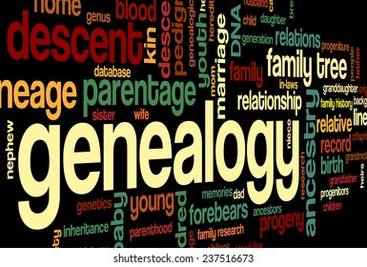

 10 Steps to Move Beyond the Census Search

1. Estimate birth, marriage, and death years

Starting in the 1850s, each census year provides the approximate age and place of birth for each person recorded, allowing you to easily calculate a year of birth.

Marriage tip: To estimate a marriage year for a couple, examine the birth date of a couple’s oldest child and subtract a few years.

Death year tip: If you notice an ancestor who disappeared from the census, be sure to check death records as you can look in the decade following their last appearance for a death record.

2. Trace a family’s immigration

Later census years provide the year of immigration, which can help narrow your search. At the turn of the 20th century, almost 2 million European immigrants came to the U.S. to discover new lands, opportunities, and a better way of life. Irish famine immigrants, Germans to America, Italians to America, and Russians to America may all be found on findmypast.com.

Tips: Because immigration information may be inaccurate, be sure to search records a few years before and after the date recorded in the census. Pay attention to the date of immigration for all children as families may not have traveled to the U.S. at the same time and could be on different passenger lists.

3. Discover your ancestor’s employment records

Use occupation information from the census to search for work records for nurses, doctors, lawyers, farmers, merchants, etc. enumerated in the census.

4. Check the neighbors to find more relatives

Be sure to look at the families living next to your ancestors, which might be relatives (i.e. in-laws or siblings).

Tip: Look for patterns in birthplaces, occupations, and other details as you look at those enumerated on the same page as the family you are researching.





5. Learn about military service

Some census years provide information on an ancestor’s military service, listing from the Revolutionary War to World War II. The 1840 census is the first to list ages, but only of war veterans. For example, in the 1840 census, the names and ages of surviving Revolutionary War soldiers receiving pensions are listed on the second page and can lead to military and pension records.

6. Look for children not listed

Remember, the census is only a single snapshot of a family on a given day and may be incomplete. Beginning in the 1900 U.S. census, records list the number of children a mother has and how many are living.

Tip: Look for gaps between ages of children, as a child may have died young, moved out of the house, or be living/working outside of the family’s home when the census enumerator visited.

7. Examine naturalization dates

How to read census abbreviations: Columns marked “Na” indicate the individual was naturalized, while “Al” indicates they had not yet begun the process.

8. Look for land ownership

If someone owned land, be sure to search local land records for information on the sale of the property. Land records can answer questions about relationships, dates of migration, and maiden names.

9. Find ancestors in yearly city directories

Most cities in the U.S. publish a directory of their residents annually, which can provide a year-by-year timeline of the family. Start with the year of the census and work backwards or forwards as needed. Directories may include a family’s arrival or departure to an area, address changes, and significant events like marriages, divorces, and deaths.

10. Look for state censuses

Some states (Iowa, New York, Massachusetts, Rhode Island) took a state census to bridge the gap between the federal census years. For example, New York state census records occurred every ten years starting abound 1825 and continue past 1925 in several areas.

Things to Do When You Are Stumped in Family Research

1. Explore Name Variations in Your Findings

Often U.S. ancestry records contain misspellings due to immigration and incorrect birth dates. Take time to analyze your findings and give everything another look, especially for conclusions you may have made that cannot be verified from records you have found. Avoid making assumptions and ensure that each name, event, and place can be verified before continuing your research.

2. Browse Record Collections

There are certain overlooked record collections that may add depth to your research. They include: U.S. Immigration Records, World War II Army Enlistment Records, Crime Prisons and Punishments, and Chelsea Pensioners’ discharge documents 1760-1887. If you are unable to find an answer in a specific record, consider browsing though its pages. Sometimes names were misspelled or incorrectly indexed. It is also possible the first or last name you are searching for is different than what was recorded.

3. Find Family Stories in Newspapers

4. New Records = New Opportunities

Some families are easier to find than others. As more records become available online, it is possible that the answers to your toughest research problems can be solved.

5. Create a Family Tree

Chart out a chronological timeline of a family to help stay organized and identify missing information. Include significant dates for each family member (i.e. birth, marriage, death records, length of military service, etc.).

6. Search for Siblings in Family Lines

A brother or sister might provide the names of their parents in a record while your own direct ancestor did not. Tracing wide instead of deep into family lines can also identify distant cousins, aunts, and uncles who may have useful information.

7. Go Social with Other Family Historians

Multiple resources exist for reaching out to other genealogists for ideas and advice when you are stumped. Some of these include: findmypast, Facebook, and Twitter.

8. Consult a Professional Genealogist

These people can assist you in breaking brick walls; they often work at an hourly rate and specialize in a specific record type, locality, time period, or subject matter. The Association of Professional Genealogists provides an online directory searchable by specialty to assist you.

9. Locate the Original Record

Sometimes, you may be looking at a transcript or abstract made from an original record. It is essential to examine a copy of the original record to help yield additional information for research. Tip: In order to locate the original record, you must keep track of your findings.

10. Visit a Genealogical Library

The world’s largest genealogical library, The Family History Library, is located in Salt Lake City, Utah, and has a worldwide collection of over 2.4 million rolls of microfilm and thousands of books. Other prominent genealogical research libraries include: The Genealogy Center at the Allen County Public Library in Fort Wayne, Indiana, the Daughters of the American Revolution Library in Washington, D.C., the Midwest Genealogy Center in Independence, Missouri, the Clayton Library Center for Genealogical Research in Houston, Texas, and the New England Historic Genealogical Society’s Library in Boston, Massachusetts.

11. Visit a Public Library Near You

Your local library might have access to databases and records to help you expand your search; in some cases, you may be able to access materials remotely without having to visit the library itself.

12. Participate in a DNA Study

Many individuals participate in DNA surname studies which combine genealogical research and DNA results to prove relationships between individuals and potential origins of certain surnames or groups.

13. Subscribe to a Genealogical Journal

These journals can include record abstracts and published family sketches demonstrating the research process and solve some of the toughest questions. Even if an article has not been published on your family these articles provide sources and techniques you may apply to your own research. Such articles include: The American Genealogist, the National Genealogical Society Quarterly, The New York Genealogical and Biographical Record, and The New England Historical and Genealogical Register.

14. Search for Printed Resources

While there are several records that may be found online, there are thousands not available in that format yet. Printed resources include genealogies, local histories, record transcriptions and abstracts, and other materials.

15. Think Outside the Record Set

Many offline records are available at libraries and archives across the U.S. and world. Manuscript collections can often be invaluable for research as they contain unique personal records such as letters, diaries, and photographs not found anywhere else. ArchiveFinder and ArchiveGrid are two resources that can help find other collections to continue your research.

10 Ways to Research Your Family Tree for Free

1. Public libraries

Libraries across the country offer card-holding residents free access to popular genealogy websites and information. Look for genealogy research options on your local library’s website or call and ask.

2. Allen County Public Library Genealogy Center

They include resources for Allen County, the entire state of Indiana and other states, as well as military veterans, Native Americans, and African Americans. You do not need a library card and can access the genealogy center’s free databases online.

3. National Archives

The National Archives and Records Administration holds a mass of civilian records. Those commonly used for family research include records for the following: census, military service, immigration, naturalization, and records of transfers of public lands from the federal government to private ownership. Some of these are accessible online, while others are accessible only at certain National Archives facilities where you may enjoy free access to databases like ancestry.com.

4. Statue of Liberty-Ellis Island Foundation

These resources include records of millions of passengers who reached the U.S. through Ellis Island and the Port of New York between 1892-1924. The records are available at the American Family Immigration History Center in the Ellis Island National Museum of Immigration and on the foundation’s website.

5. The USGenWeb Project

This project is “a group of volunteers working together and having fun providing free online genealogy help and information for every U.S. state and country.” It offers links to state websites, which offer links to county websites. The resources available here are: listings of local sources for records, county and state histories, online genealogy books, research tips, maps, and links to other resources.

6. AccessGenealogy

This group boasts the largest collection of free resources for U.S. genealogy research, including hundreds of thousands of free websites. Its specialty is Native American history and genealogy.

7. Afrigeneas

This group is dedicated to African-American genealogy, and available resources through the site include: photos, a slave data collection, a surname database, marriage record databases, and death record databases.

8. Family Search

This is the largest genealogy organization in the world and is associated with the Church of Jesus Christ of Latter-Day Saints. You may search the nonprofit’s billions of records and start your own family tree by signing up for a free account at FamilySearch.org.

9. Find A Grave

If you are just beginning genealogy research, Fine A Grave contains a large collection of information from and photos of gravesites contributed by community members. These are people who have registered for a free Find A Grave account and that can use the site to add a memorial or search the 180 million memorials already created.

10. Chronicling America

This website is sponsored by the U.S. Library of Congress and National endowment for the Humanities. It provides access to select digitized newspaper pages from the years 1789-1963, which may reveal an interesting face about a relative. You may search for a family member’s name and filter the search by state and date range, or use the Advanced Search tab.

